Living *Laudato Si’*:

Your Parish and Your Planet

Zoom Retreats in 2021

12th-16th March & 16th-19th April

(led from Boarbank Hall, Cumbria)

**WHY?** Faith is the place to start.

**WHAT?** Understanding is the place to start.

**HOW?** Sharing experience is the place to start.

**WHEN?** Now is the place to start.

**WHERE?** Your parish is the place to start.

**WHO?** Are YOU the place to start?

**What will happen?** A long weekend of talks and discussions on zoom, and practical activities, on living the message of *Laudato Si’* in and through your parish.

**Who is it for?** Any interested parishioner is most welcome to join us. The weekend is aimed especially at people with parish responsibilities or who are part of or want to start a relevant parish group.

**Timings** Sessions will be on Friday night, Saturday morning and night, Sunday afternoon and night and Monday night (leaving people free during the day on Monday).

**Speakers include:**

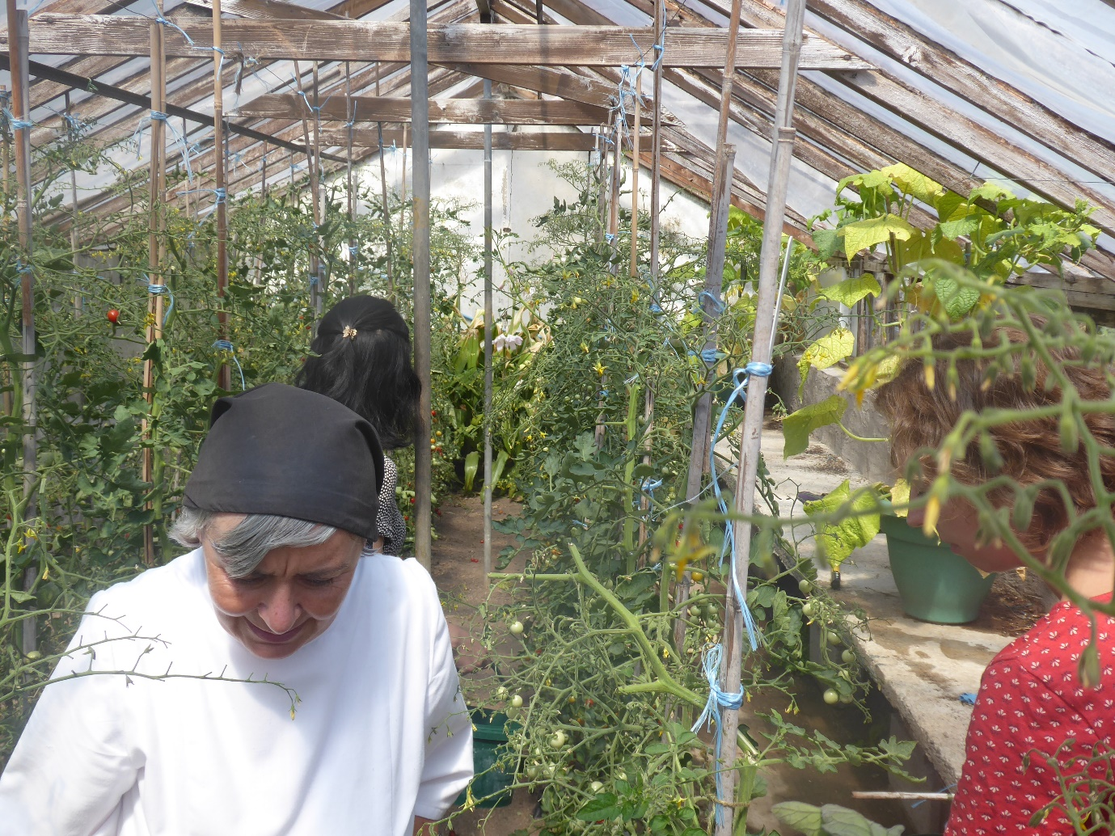

***Trish Sandbach***, who worked in Oxfam Education for many years and led St Benedict’s, Garforth, in the Leeds diocese, to winning a *Live*simply award. She is also an assessor for the *Live*Simply award [www.cafod.org.uk/Campaign/Livesimply-award](http://www.cafod.org.uk/Campaign/Livesimply-award).

***John Paul de Quay*** and ***Ellie Margetts***, founder members of the Ecological Conversion Group and *Journey to 2030* [www.journeyto2030.org](http://www.journeyto2030.org).

***Sr Margaret Atkins***, an Augustinian Canoness at Boarbank Hall in Cumbria, a teacher of philosophy and theology, with a lifelong interest in the natural world, and author of *Catholics and Our Common Home: Caring for the Planet in a Time of Crisis* (CTS).

[www.ctsbooks.org/product/catholics-and-our-common-home](http://www.ctsbooks.org/product/catholics-and-our-common-home)

***Archbishop John Wilson*** and ***Bishop Peter Brignall*** (March) and ***Archbishop Bernard Longley*** and ***Bishop Marcus Stock*** (April)will begin and end the weekends with prayer and reflection.

Panel discussions with a range of experts for sharing advice on practical projects.

**Cost - voluntary donations gratefully accepted**, but there will be no fee for the weekend.

**To apply**, simply email Sr Margaret Atkins on [margaret@boarbankhall.org.uk](mailto:margaret@boarbankhall.org.uk).